**Name:** Safyan Anwar

**Roll no:** -018

**Section:** 3A-BSSE

**Assignment #:** 5

**LAB TASK:**

**Code:**

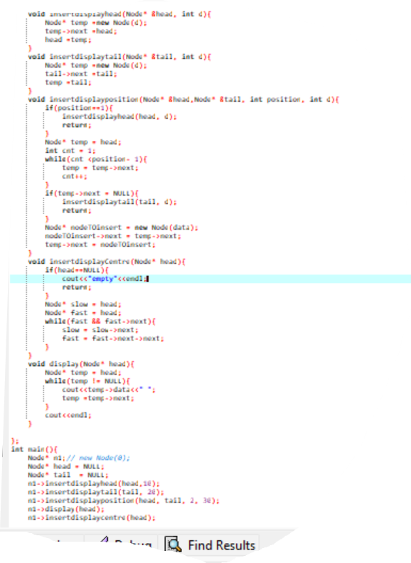

**Output:**

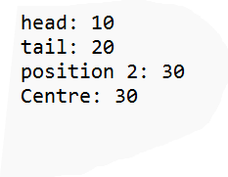

**Explanation:**

I first of all create class ‘Node’ and hold the value int data and pointer to the next node.

I create methods in this node; ‘insertdisplayhead’ inserts a new node at the beginning of the list.

‘Insertdisplaytail’ inserts a new node at the end of the list. ‘insertdisplayposition’ inserts a new node at a specific position in the list. ‘insertdisplayCentre’ display the middle node of the list by using the slow and fast pointer method. ‘Display’ print the list head to tail and the main function you see in a code or code file.